**Shopping: Non-Catalog Orders: Xerox**

How to Create a Xerox Non-Catalog Order

**Quick Steps:**

From the AggieBuy Homepage:

1. Click Non-Catalog Item
2. Choose the supplier (Xerox Corporation)
3. Verify the fulfillment address
4. Enter the item description, catalog number, quantity, price, and packaging information
   * Line 1: Base Monthly Rate
   * Line 2: B/W Prints
   * Line 3: Color Prints
5. Click “Save”
6. View the cart and adjust any applicable optional fields
   * Check the “Route to Procurement Services Box)
7. Click “Proceed to Checkout”
8. Click “Submit Order”
9. The requisition will route to Procurement Services
10. On the AggieBuy homepage and click “Non-Catalog Item”

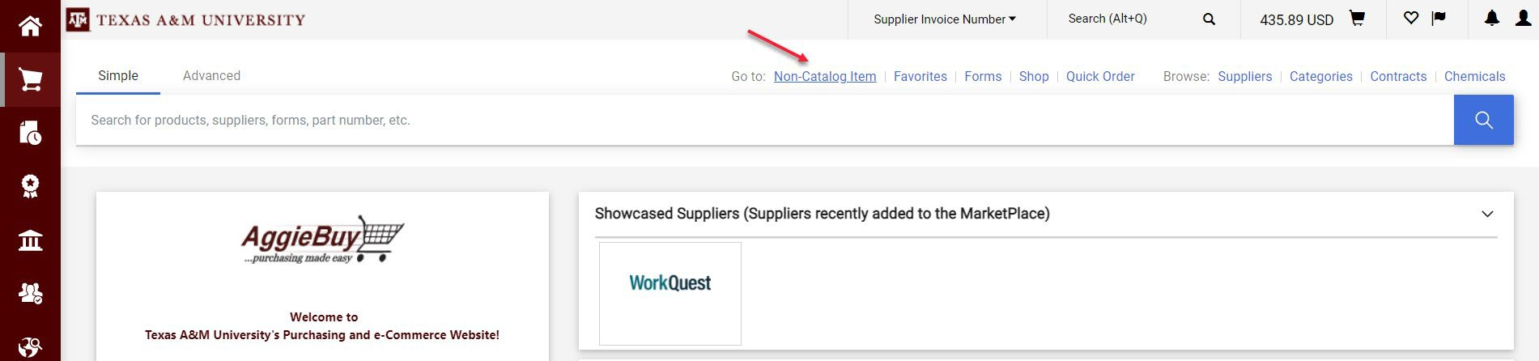

1. Choose the supplier by typing the name of the supplier and then choosing from the list of options. Choose Xerox Corporation when working with Kyle Office Products.

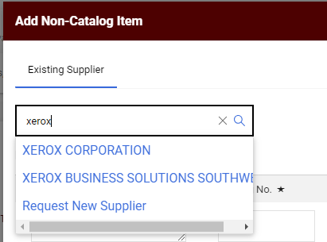

1. Choose the Fulfillment Address: PO Box 802555

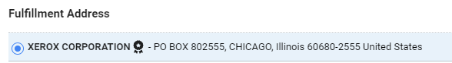

1. Enter the item description, catalog number, quantity, price, and packaging information.

Product Description: Item description should include the term and the start and end dates (48 months and 4/1/24-3/31/28 respectively, in the example below).

Catalog Number: Model of the Xerox machine we are leasing.

Quantity: Number of months left in the current fiscal year **after** expected start date, which is typically one month after the PO is issued. The lease starts when the machine is delivered.

Price Estimate: Monthly lease rate quoted by the supplier.

Packaging: EA

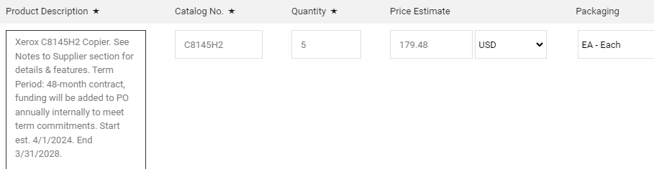

1. Click “Save and Add Another”

The second line should always be for B/W prints. The quantity is estimated.

The price should be the overage price quoted by the supplier.

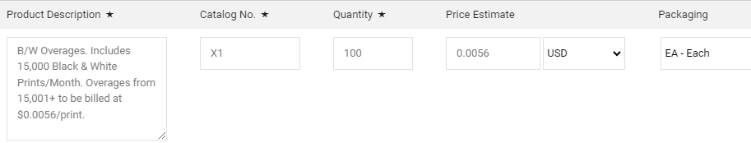

1. Click “Save and Add Another”

The third line should always be for color prints. The quantity is estimated by the supplier.

The price should be the color charge rate quoted by the supplier.

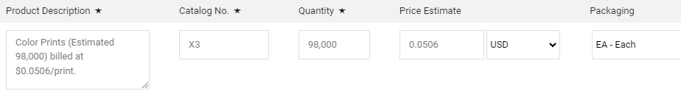

1. Click “Save”

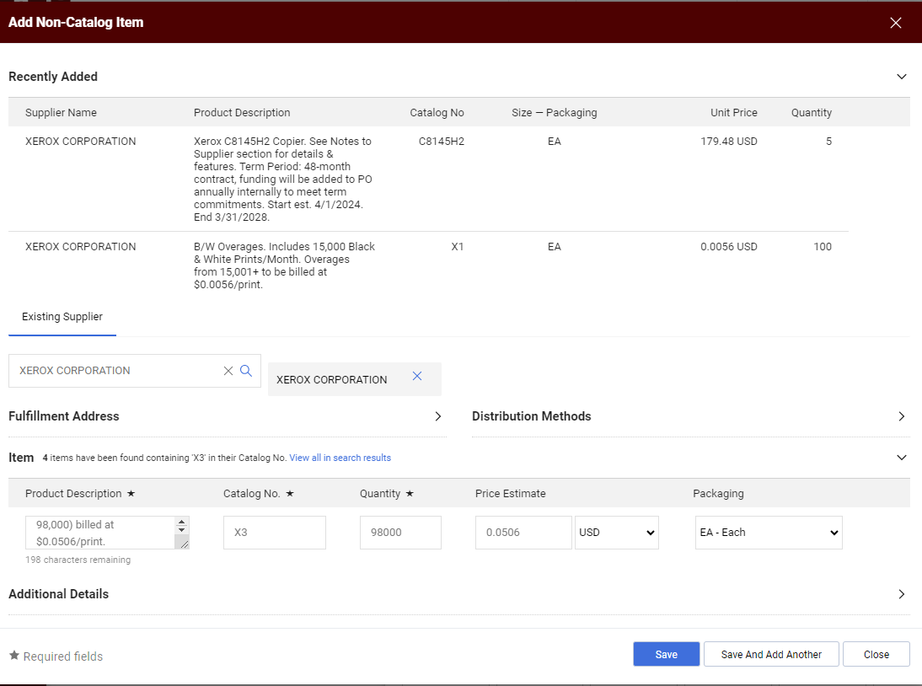

1. Click on your shopping cart

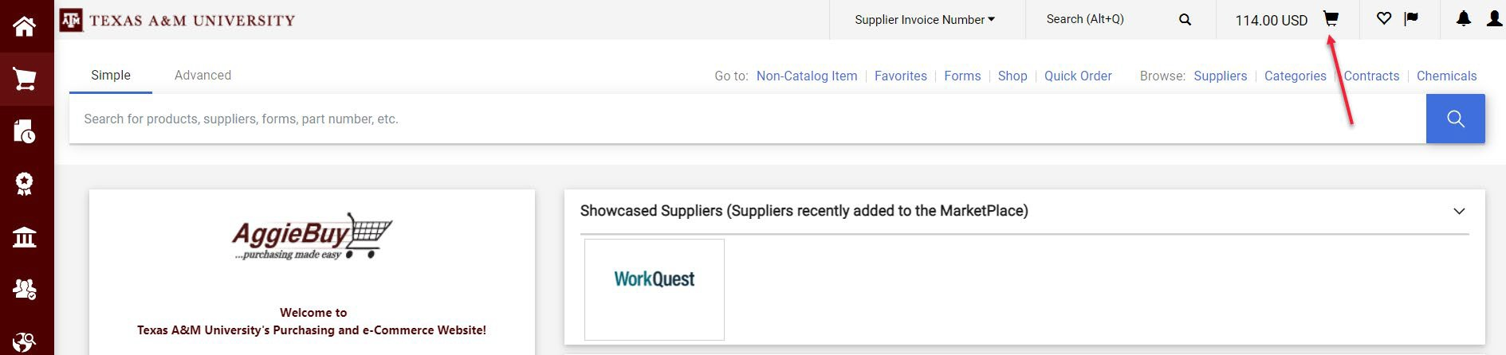

1. Then click “View My Cart”

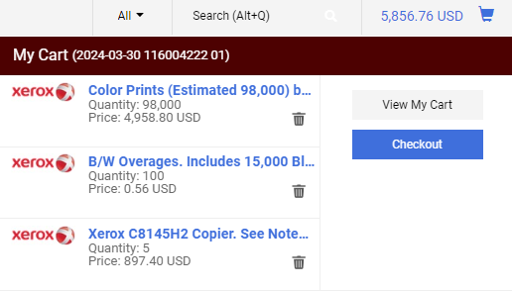

1. “Order Category” should be “Regular”

Check the “Route to Procurement Services” box.

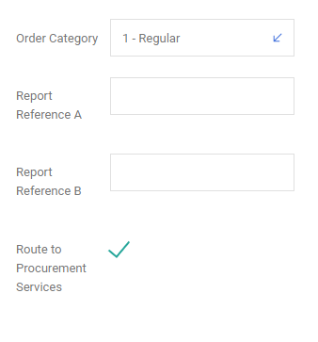

1. The “Cost Receipt Required” checkbox is normally left blank.

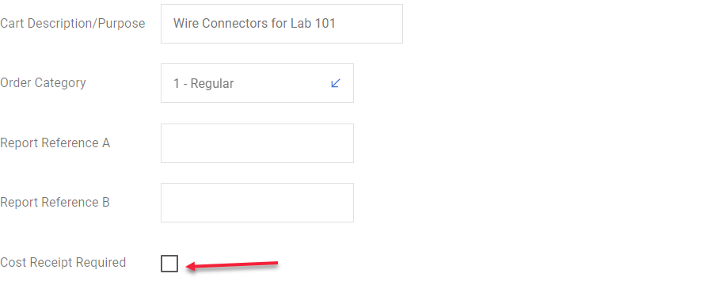

1. Once this screen has been completed you may click “Proceed to Checkout”

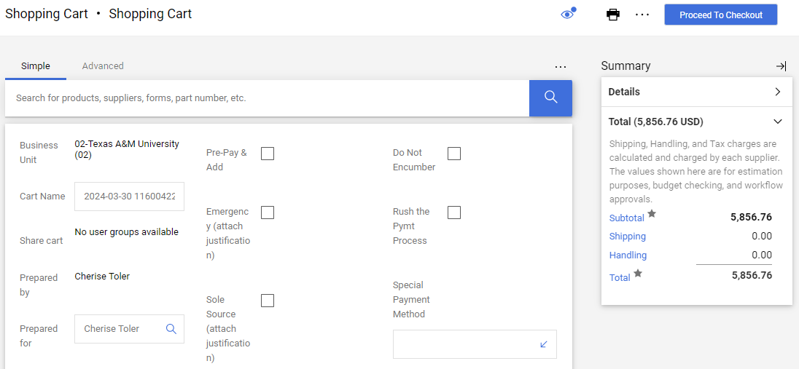

1. Click “Submit Order”

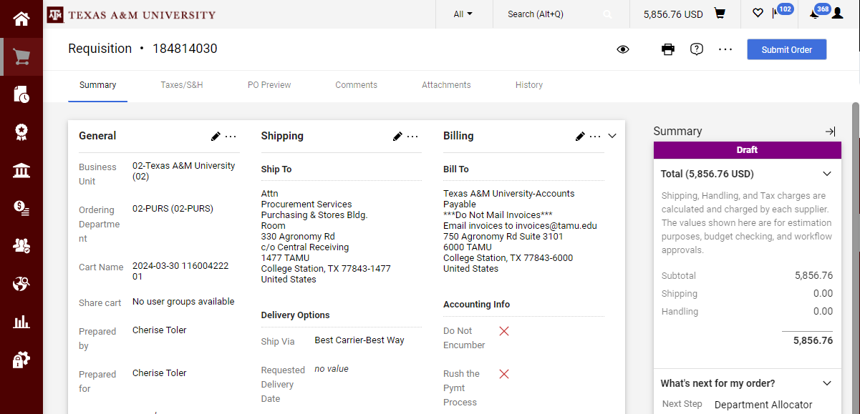

1. The requisition will route to Procurement Services for additional preparation before the PO is dispatched to the supplier.