**Shopping: Non-Catalog Orders: Ricoh, CTWP, UBEO**

**Quick Steps:**

From the AggieBuy Homepage:

1. Click Non-Catalog Item
2. Choose the supplier
3. Verify the fulfillment address
4. Enter the item description, catalog number, quantity, price, and packaging information – One line for each fiscal year
5. Click “Save”
6. View the cart and adjust any applicable optional fields
   * Check the “Route to Procurement Services” Box
7. Click “Proceed to Checkout”
   * Check Ship-To Address
8. Click “Submit Order”
9. The requisition will route to Procurement Services
10. On the AggieBuy homepage and click “Non-Catalog Item”

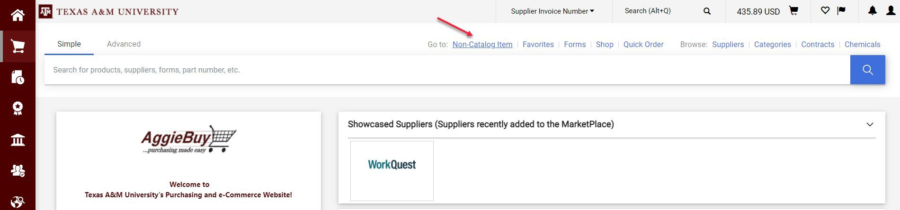

1. Choose the supplier by typing the name of the supplier and then choosing from the list of options. Choose Ricoh USA.

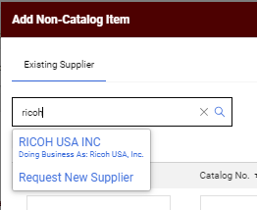

1. Choose the Fulfillment Address: PO Box 802555



1. Enter the item description, catalog number, quantity, price, and packaging information.

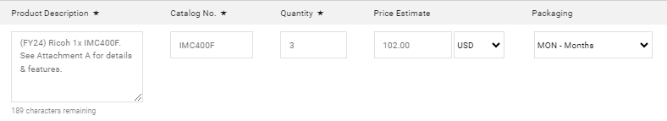

**Product Description:**  Item description should include the applicable fiscal year, the machine model,

and the statement “See Attachment A for details and features.”

Procurement Services will create the Attachment A and attach it before the PO is sent to the supplier

**Catalog Number:** Best practice is to enter the machine model number. This is useful for reporting

purposes.

**Quantity:** First line: The number of months left in the current fiscal year **after** expected start date,

which is typically one month after the PO is issued. The lease starts when the machine is delivered.

Middle Lines: 12 Months

Last Line: The number of months left in the lease during the last fiscal year. If the lease started in FY

24 on June 1, the number of months on line one would be three. This means the last year of the

lease, we would have 9 months of that Fiscal Year left on the lease.

**Price Estimate:** Monthly lease rate quoted by the supplier.

1. Click “Save and Add Another”

Add additional lines – one for each additional fiscal year in which the lease will be active. The first line and the last line should equal 12 (1 year).

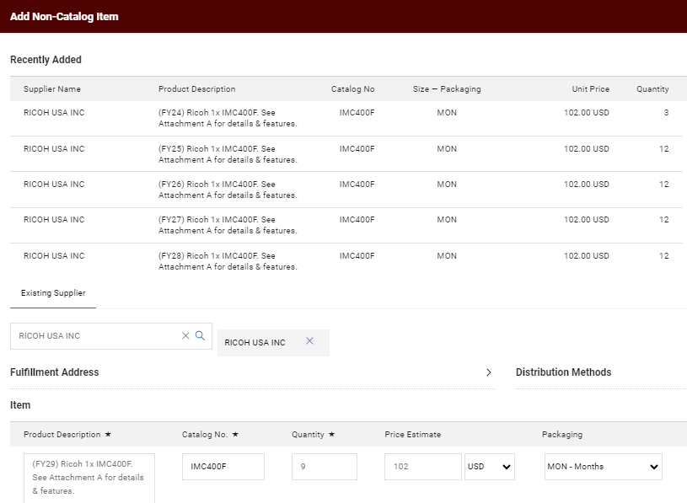

1. Click “Save”
2. Click on your shopping cart

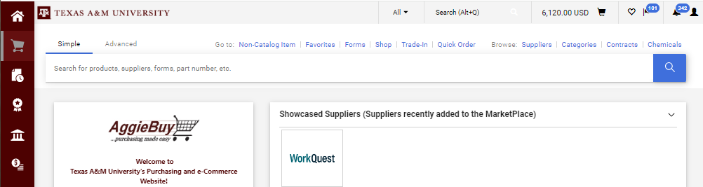

1. Then click “View My Cart”

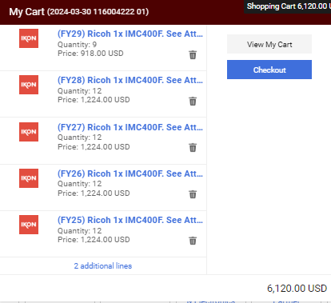

1. “Order Category” should be “Regular”

Check the “Route to Procurement Services” box.

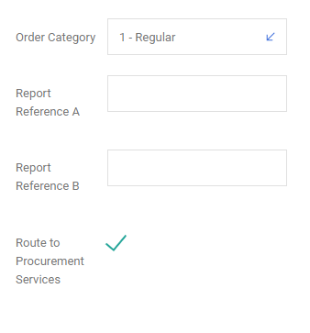

1. Once this screen has been completed you may click “Proceed to Checkout”

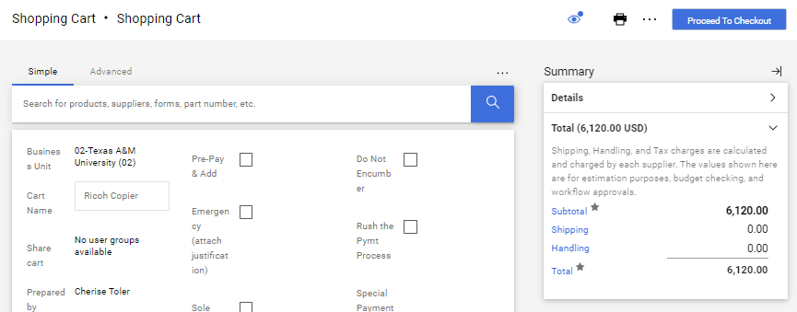

1. Confirm correct Ship-To address

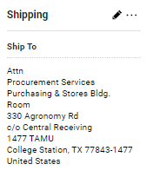

1. Click “Submit Order”

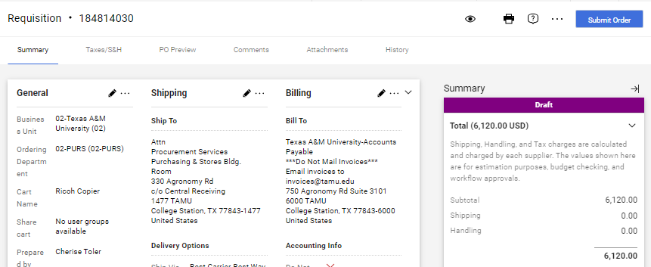

1. The requisition will route to Procurement Services for additional preparation before the PO is dispatched to the supplier.
2. The PO will be cancelled in AggieBuy to prevent duplication of invoice payments or encumbrances.

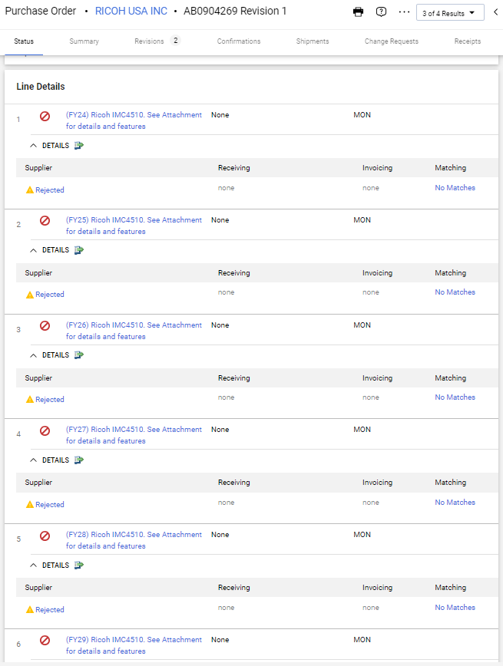

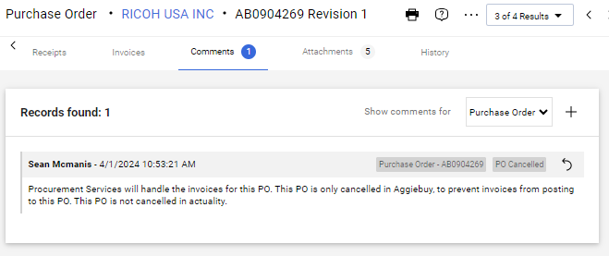

1. Invoices will be sent to Procurement Services for review and then paid by FMO. Procurement Services typically receives one large invoice for all POs in the program. After review, the invoices are sent to FMO for payment. The payment comes from Procurement Service’s account and then applicable amounts are IDT’s from each department’s account. The department’s account is the account that was used on the PO when it was issued.
2. To Search for Paid Consolidated invoices, use the following invoice search filters:

Created Date: Last 30 Days

Supplier: Ricoh, CTWP, or UBEO

Invoice Status: Complete

Invoice Type: Non-PO Invoice

Invoice Owner: Benford, Lewis

You may also reach out to Procurement Services to inquire about consolidated invoices.

